FROM THE BOTTOM UP

**How Recent Legislation Re-Writes Affordable Housing in New Jersey**

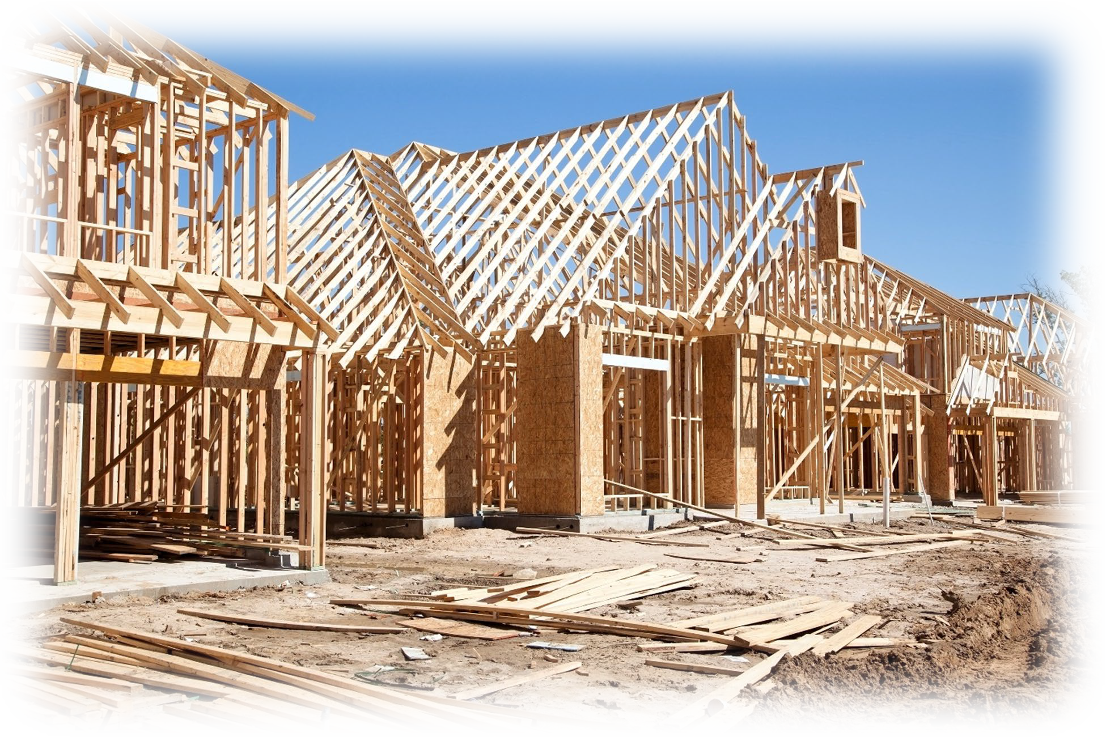

# October 2024

**BY:**

**Victoria D. Britton, Esq. Jason Hyndman, Esq.**

**Edward W. Purcell, Esq.**

[**www.pricemeese.com**](http://www.pricemeese.com/)

**(201) 391-3737**

On March 20, 2024, Governor Murphy approved legislation to streamline the process for municipalities to comply with the Mount Laurel Doctrine-i.e. the State’s Constitutional mandate that each municipality is obligated to affirmatively create a realistic opportunity for the development of sufficient low and moderate income housing. The legislation, assembly bill A-4 (“A-4”) made significant changes to the Fair Housing Act (“FHA”). These changes are going into effect just before the new ten

(10) year municipal compliance round, the 4th round, is set to begin in 2025. A-4 represents a substantial revision of the statutory framework enacted to ensure compliance with the Mount Laurel Doctrine. Importantly, A-4 clarifies the methodology for quantifying municipal fair share obligations, i.e. their present and prospective need for the creation of affordable housing. It also significantly revises how bonus credits are calculated and provides new incentives for additional types of housing, including family units, redevelopment and supportive housing. It also completely reworks the process by which municipalities can obtain immunity from “builder’s remedy” lawsuits – i.e. exclusionary development lawsuits brought by developers to effectively set aside a municipality’s zoning regulations applicable to a site, so that affordable housing may be constructed there.

With respect to process, A-4 abolished the long defunct Council on Affordable Housing (“COAH”) – the State agency previously tasked with the administration of affordable housing. Rather than proceed through COAH, municipalities which wish to retain their immunity from builder’s remedy lawsuits must either proceed before

a dispute resolution process the “Program” (and be subject to very tight deadlines) or obtain a declaratory judgement from a county level housing judge.

# The Process: The “Program” & County Level Housing Judges

A-4 creates a dual track for municipalities to obtain immunity from exclusionary development lawsuits – the Program and the county level housing judges. The Program will be managed by the Administrative Office of the Courts (“AOC”) and will resolve disputes related to municipal fair share obligations and mediate disputes regarding whether a municipality’s Housing Element and Fair Share Plans (“HEFSP”) meets its affordable housing obligations. Because there are strict deadlines which direct how the Program operates, it is important to understand those deadlines before we analyze the substance of how the Program will decide on municipal obligations and mediate HEFSP disputes.

Those dates are as follows:

1. With respect to fair share obligations, A-4 directed the Department of Community Affairs (“DCA”) to issue an advisory report on the present and prospective need obligations for the entire state. This report is now available online[1] and has estimated a total present need obligation of 65,410 housing units and a total (uncapped) prospective need obligation of 84,698 housing units for the 4th round. These calculations are not binding on municipalities or any other entity, and municipalities are free to determine their own present and prospective need calculations based on the updated methodology set forth in A-4.
2. Municipalities participating in the Program must adopt resolutions establishing their 4th round fair share obligations no later than **January 31, 2025**. Within **48 hours** of adopting such a resolution, a municipality must file an action with the Program for approval of same.
3. Interested parties must file all challenges to municipal calculations with the Program by **February 28, 2025**.
4. The Program shall resolve all such challenges to municipal calculations by **March 31, 2025**.
5. Municipalities must adopt their HEFSP no later than **June 30, 2025**.

Municipal HEFSPs must include draft (zoning) ordinances and resolutions to implement municipal present and prospective need calculations. Municipalities must file their adopted HEFSPs with the Program within **48 hours** of adoption.

1. Interested parties must file any challenges of municipal HEFSPs with the DCA program no later than **August 31, 2025**.
2. The Program will facilitate communication between the municipality and any interested parties regarding any challenge and seek to mediate a solution. Municipalities have until **December 31, 2025,** to resolve any challenge to their HEFSP. If a challenge is resolved, the Program will issue a compliance certification conditioned upon the municipality’s commitment, as necessary, to revise its HEFSP. If the dispute is not resolved by **December 31, 2025**, the matter will be transferred to a county level housing judge for a decision.
3. All ordinances and resolutions implementing a municipal HEFSP must be adopted by **March 15, 2026**. After adoption, said HEFSPs must be immediately filed with the Program. In lieu of adopting implementing ordinances, a municipality that is involved in a dispute of its HEFSP may adopt a binding resolution by **March 15, 2026,** to commit to adopting the implementing ordinances and resolutions following the resolution of the dispute, with necessary adjustments to reflect said resolution.

A-4 provides some guidance on how the Program is meant to decide disputes regarding affordable housing obligations, mediate disputes about municipal HEFSP and in what situation a municipality would lose immunity. With respect to reviewing a municipality’s obligation calculations, A-4 directs the Program to “apply an objective assessment standard to determine whether a municipality’s present and prospective need calculation is compliant [with the need calculation requirements of A-4].” Additionally, when reviewing a challenge to a municipality’s need calculations, the Program has three (3) options to resolve the dispute. It can: 1) determine that the municipality’s affordable housing number “did not facially comply with the requirements of [A-4];” 2) adjust the obligations without revoking immunity; or 3) reject a challenge and affirm the municipality’s determination. Thus, to the extent that a municipality’s calculations are somewhat “in the ballpark,” the Program is directed to modify the calculation but, to the extent that the calculations are not even “facially” compliant with A-4, a municipality would lose immunity.

A-4 similarly sets forth some substantive direction in how the Program is meant to review challenges to a municipality’s adopted HEFSP. If no one challenges

a municipality’s HEFSP by August 31, 2025, then the Program is directed to conduct a limited review of the HEFSP to confirm compliance with the FHA and Mount Laurel Doctrine. If there is a challenge filed, then the Program mediates between the objector and the municipality. Municipalities have until December 31, 2025, to (i) commit to revising their HEFSPs to comply with the changes requested in any challenge, (ii) provide an explanation as to why they will not make the requested changes, or (iii) both. If a challenge is not resolved by December 31, 2025, then the dispute is transferred to a county level housing judge who will adjudicate the matter through a “summary proceeding.”

Importantly, A-4 also sets forth what are, and are not, legitimate basis to challenge a municipality’s HEFSP. A-4 provides that an interested party that files a challenge “shall specify with particularity which sites or elements of the municipal fair share plan do not comply with the Fair Housing Act or the Mount Laurel doctrine, and the basis for alleging such non-compliance.” Importantly, A-4 provides that such a challenge “shall not include a claim that a site on real property proposed by the interested party is a better site than a site in the plan.” Consequently, when an interested party challenges a HEFSP, that challenge must be focused on the non- compliance of the existing plan, not that the interested party’s site is better.

A-4 gives the Program wide latitude to “terminate [a municipality’s] immunity if it finds that the municipality is not determined to come into compliance at any point in the process.” This language effectively gives the Program the ability to look at a municipality and determine that, where a municipality is not really making a good

faith effort, there is little likelihood that the municipality will voluntarily come into compliance. In those situations, A-4 permits the Program to terminate immunity.

A municipality or interested party can appeal the Program’s decisions related to affordable housing calculations. However, because A-4 directs the AOC to create the appellate mechanism, there is a palpable lack of clarity on this issue. However, and importantly, A-4 makes it clear that an appeal of the Program’s determination with respect to need calculation, does not “pause” a municipality’s deadline to file its HEFSP and implementing ordinances with the Program. Thus, even if a municipality disagrees with the Program’s decision it will be required to continue with the Program or risk losing immunity.

Municipalities also have the option to forego the Program and seek a “compliance certification” by way of a declaratory judgement (“DJ”) action filed with a county level housing judge. This would be akin to seeking a judgement of compliance and repose—something which municipalities have regularly done in the 3rd round. However, unlike those municipalities in the 3rd round, and unlike municipalities that participate in the Program in the 4th round, a municipality that seeks “a compliance certification” from a county level housing judge under A4 would not be immune from builder’s remedy lawsuits during the pendency of the action. Consequently, while this is an option for municipalities in lieu of the Program, it does have drawbacks.

# Calculating Need. Methodology and Caps on Prospective Need.

A-4 adopts a single methodology for determining prospective need, i.e. the amount of affordable housing required to be created during the next 10 year period- in this case the 4th round. In large part, A-4 adopts the methodology established in the unpublished trial level decision In Re Municipality of Princeton. Docket No.:

MER-L-1550-15 (Law Div. 2018), which also formed the basis for prospective need calculations throughout the state. As set forth above, the DCA has published an advisory report on municipal prospective need obligations using the methodology set forth in A-4. Municipalities can adopt this number or, alternatively, they can adopt a different number based their own calculations, provided that the same methodology is employed. This essentially limits municipalities to supplementing or revising the underlying demographic and development data.

A-4, like the FHA previously, creates a cap on prospective need. Specifically, A-4 provides that a municipality’s prospective need must be set at the lower of: 1) one thousand (1,000) housing units, after the application of an excess credits; or 2) twenty percent (20%) of the total number of households in a municipality according to the most recent federal decennial census. Furthermore, A-4 specifically provides that unfulfilled obligations from prior rounds does not count towards the cap on prospective need.

# Meeting the Obligation. Redevelopment, Bonus Credits & Set-Asides.

A-4 will have a significant impact on how many urban and suburban municipalities utilize their redevelopment powers to satisfy their respective affordable housing obligations. Previously, it was generally understood that the municipal obligation was limited to zoning for a reasonable opportunity for the private market to develop the municipality’s fair share of affordable housing; with more active involvement in the development process by the municipality only when the municipality sought to prevent or limit specific proposed developments. However, A-4’s mandate to affirmatively account for redevelopment opportunities signals an enhanced obligation of municipalities to ensure the development affordable housing.

The clearest signal for this enhanced obligation and corresponding redevelopment directive is the imposition of the redevelopment planning process directly into each municipality’s HEFSP. A-4 revises the Municipal Land Use Law (“MLUL”) with respect to the mandatory elements of the HEFSP, to require that municipalities must “plan for infrastructure expansion and rehabilitation and conversion or redevelopment of unused or underutilized real property, including existing structures, if necessary to assure the achievement of the municipality's fair share of low- and moderate-income housing.” Coupled with the longstanding initiatives that many municipalities have incorporated into their existing master plans, specifically identifying struggling commercial districts and/or emphasizing the revitalization of existing downtowns, this provision of A-4 opens the door for challenges to fair share plans in municipalities that have a history of identifying

underutilized retail/commercial properties in their planning documents, but whose fair share plan does not include multifamily/mixed use development into these downtown and commercial districts. Moreover, the explicit mandate to plan for the necessary infrastructure improvements to accommodate future growth may, over time, erode the validity of a municipality’s claim that certain areas cannot be upzoned due to lack of sewer capacity, poor storm water management, or poor traffic conditions – as challengers to a HEFSP can argue that a municipality’s failure to address longstanding infrastructure issues is demonstrative of recalcitrance to construct affordable housing. By emphasizing the need for redevelopment as a necessary component of the HESFP, municipalities are being set up to take a more affirmative role in the planning and development of affordable housing.

The second significant emphasis on redevelopment relates to the treatment of unmet need in the 4th and subsequent rounds. In the prior rounds, development of affordable housing was presumptively contemplated to be provided primarily on vacant land in developing communities. Thus, communities were considered “fully developed,” and obligations would be reduced, when there were limited parcels of vacant land that were large enough to accommodate at least five (5) multifamily units. In most suburban municipalities, that required an acre of land to satisfy the presumptive density under COAH’s regulations. Those regulations did not account for demand or underutilization of developed parcels.

Consequently, in prior rounds, municipalities could limit their prospective need obligations through vacant land adjustments. Once the prospective need was

adjusted to a lower, “Realistic Development Potential”, based on the available vacant land for development, the difference between the default prospective need and the “Realistic Development Potential” was classified as “unmet need” and the municipality would only need to adopt passive measures to allow for additional affordable housing development during the current round, but with no obligation to demonstrate that the proposed measure would sufficiently address that “unmet need” and no requirement that any additional affordable housing units actually be developed.

However, with the adoption of A-4, the legislature has now required municipalities that are utilizing a vacant land adjustment to affirmatively address at least 25% of the “unmet need” by identifying “parcels likely to redevelop during the current round of obligations” and adopt realistic zoning for those various parcels that would provide the affordable units to address 25% of the “unmet need.” This puts significant pressure on municipalities to comprehensively zone for redevelopment or demonstrate to the court’s satisfaction why 25% of the unmet need cannot be achieved through the redevelopment of land within the municipality. As a result, developed yet underutilized parcels can be leveraged by interested parties to challenge fair share plans. Moreover, this change incentivizes upzoning existing mixed-use zones and introducing residential uses in exclusive commercial districts.

A-4’s significant amendment of the bonus credits structure heavily favors redevelopment. With the 25% cap on bonus credits and the prohibition on applying multiple eligible bonus credits to a single eligible unit remaining in effect,

the legislature’s elimination of the blanket 1 to 1 rental bonus credit essentially replaces the majority of bonus credits with a more targeted credit system that primarily provides for bonuses of 0.5 to 1. The following are the only types of housing units that are eligible for bonus credits under the new credit system:

* 1. Supportive housing (1 to 1 bonus)
  2. Municipal partnership with a non-profit partnership (0.5 to 1 bonus)
  3. Development within 0.5 mile of transit (0.5 to 1 bonus)
  4. Age restricted housing (0.5 to 1 bonus)
  5. Development of excess 3BR units above municipal minimum (0.5 to 1 bonus)
  6. Redevelopment of non-residential (0.5 to 1 bonus)
  7. Extension of existing affordability controls (0.5 to 1 bonus)
  8. 100% affordable developments that received a municipal contribution (1 to 1 bonus)
  9. Development of excess very low-income credits above 13% (0.5 to 1 bonus)
  10. Market to affordable conversion (1 to 1 bonus)

This modification of the credit system provides a significant shift in incentives for redevelopment. First, the elimination of the 1 to 1 bonus credit for rentals and replacement with a targeted credit system that predominantly limits half of the available bonus credits means that significantly more units must actually be developed before reaching the 25% cap. Second, various categories for bonus credits incentivize redevelopment. For example, the conversion on non-residential to residential and the development of affordable units within 0.5 miles of transit hubs targets developed, but underutilized properties. The credits available to municipally sponsored projects incentivize public expenditures, which can often be facilitated through the added powers afforded municipalities under the Local Redevelopment and Housing Law.

# Conclusion

For municipalities seeking to comply with their Mount Laurel obligations, and thus be immune from builder’s remedy lawsuits, A-4 entirely reshapes both the process and the substantive requirements for same. For developers that wish to have their properties considered for inclusion in a municipal HEFSP, A-4 effectively requires that those discussions commence as soon as possible. As set forth above, municipalities that will be participating in the Program have strict deadlines which are not that far in the future. Any developer that wishes to develop, or redevelop, a parcel as part of the 4th round, should begin talking to their municipality now and request that the parcel be included in the municipality’s HEFSP.

1. <https://www.nj.gov/dca/dlps/4th_Round_Numbers.shtml>